Bangabandhu Sheikh Mujibur Rahman Science and Technology University
Department of Computer Science and Engineering
1st Year 1st Semester B.Sc. Engineering Examination-2014
Course No: CSE-110/120/MAT204 Course Title: Discrete Mathematics
Total marks: 70 Time: 4 hours.

N.B.
- Answer SIX questions, taking any THREE from each section.
- All questions are of equal values
- Use separate answer script for each section

 |  | SECTION - A
1. | (a) | Determine whether the following sets are finite, countably infinite or uncountably infinite.  - The set of even integers  - Number of fish in Pacific ocean  - The set of real numbers between 0 and 1 | 3
 | (b) | In a class of 80 students, 50 students know English, 55 know French and 46 know German language. 37 students know English and French, 28 students know French and German, 35 Students know English and German, 7 students know none of the languages. Find out:  - How many students know all 3 languages?  - How many students know exactly 2 languages?  - How many students know only one language? | 5
 | (c) | Define partitions of a set. Consider the following collections of subsets of  S = {1, 2, …, 8, 9}. Find which of followings are a partition of S:  - [{1, 3, 5}, {2, 6}, {4, 8, 9}]  - [{1, 3, 5}, {2, 4, 6, 8}, {5, 7, 9}]  - [{1, 3, 5}, {2, 4, 6, 8}, {7, 9}] | 3
2. | (a) | Find the relation determined by the following digraph:  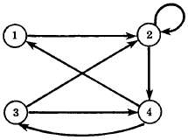  Also check whether the relation is of equivalence or partial ordering. | 2+3
 | (b) | Let A = {1, 2, 3}, B = {a, b, c}, and C = {x, y, z}. Consider the following relations R and S from A to B and from B to C, respectively.  - Find the composition relation R ͦ S  - Find the matrices M_{R}, M_{S}, and M_{R ͦ S}  - Compare M_{R ͦ S} to the product M_{R}M_{S}. | 6
3. | (a) | State whether or not each of following relations is a function from A = {a, b, c} into  B = {x, y, z}.  - f = {(a, y), (c, x)}  - g = {(a, y), (b, z), (c, x), (c, z)}  - h = {(a, x), (b, z), (c, x)} | 3
 | (b) | Consider A = {a, b, c, d} and B = {1, 2, 3} and the function f: A → B with f(a) = 3, f(b) = 2, f(c) = 1 and f(d) = 3. Examine whether the function f is to be one-to-one, onto or one-to-one correspondence. | 3
 | (c) | Define tautology and contradiction. | 2
 | (d) | Determine the validity of the argument: p → q, ~q ├ ~p. | 3
4. | (a) | - Express the statement “Everyone has exactly one best friend” as logical expression involving predicates, quantifiers with a domain consisting of all people, and logical connectives.  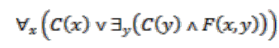  - Translate the statement: into English, where C(x) is “x has a computer”, F(x, y) is “x and y are friends”, and the domain for both x and y consist of all students in your class | 2  2
 | (b) | Show that and are logically equivalent. | 3
 | (c) | Find the dnf of the form | 4
 |  | SECTION-B
5. | (a) | Let G be the in the following figure:  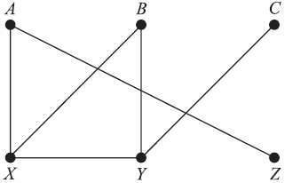  Find: (i) All simple paths from A to C (ii) All cycles (iii) G – Y (iv) All cut points and (v) all bridges | 5
 | (b) | Find the order of vertices of G in following figure are processed using DFS algorithm beginning at vertex A.  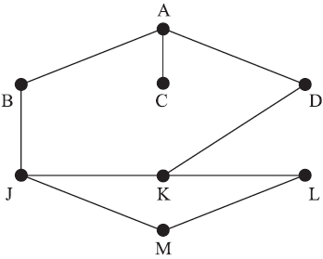 | 3
 | (c) | Find a minimal spanning tree of the following weighted graph using Kruskal’s algorithm.  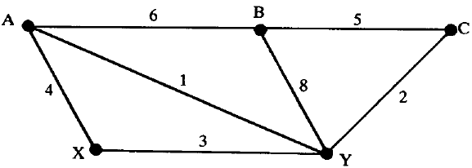 | 3
6. | (a) | Consider the graph G below. Suppose the vertices are stored in memory in an array DATA as follows:  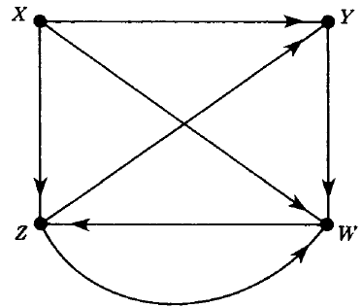  DATA: X, Y, Z, W  - Find the adjacency matrix A of the graph G.  - Find the path matrix P of G using powers of the adjacency matrix A.  - Is G unilaterally connected or strongly connected? | 2+  3+1
 | (b) | Compute the shortest distance and path from the source vertex A to other vertices using Dijkstra’s algorithm for the following graph.  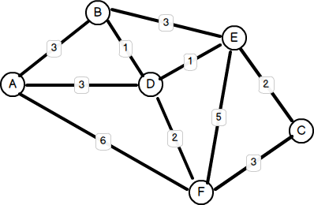 | 5
7. | (a) | Consider the weighted graph G in below, where, say, the array DATA: X, Y, S, T maintains the vertices in memory.  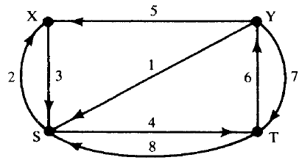  - Find the weight matrix of G  - Find the matrix Q of shortest paths using Warshall’s algorithm. | 2+3
 | (b) | Let T be the binary tree stored in memory as in the following figure, where root = 14  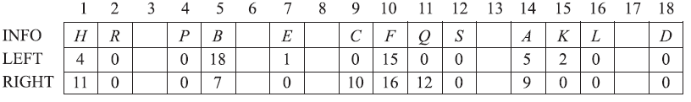  - Draw the diagram of T.  - List the nodes of T in preorder, inorder and postorder. | 3+3
8. | (a) | Consider the binary tree T in the following figure. Find the sequential representation of T in memory using only a single linear array.  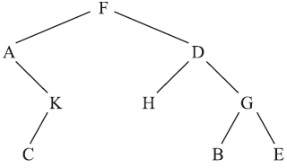 | 3
 | (b) | - Construct the binary search tree T for the following list of numbers: 50, 33, 44, 22, 77, 35, 60, 40  - Suppose the node 33 is deleted from T. Find the final tree T. | 3+2
 | (c) | Let H be the heap in the following Figure. Find the final heap H if the numbers 65, 44, and 75 are inserted one after the other into H.  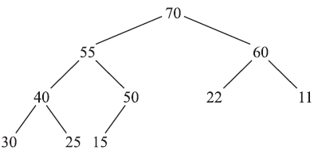 | 3

